
1:350 SCALED MODIFIED UDALOY CLASS DDG FOR ROYAL THAI NAVY (IN IDEAL)

BY SOMYOT KHUPTAWATHIN
NOTE : THIS MODEL WAS JUST AN IDEAL , NO ONE IN REALITY
This Russian Udaloy class DDG model of mine was basicly built from Chinese made kit ( I don’t know kit brand ) . Kit parts
are not good in detail ( seem to be clunky ) . So , it’s a hard job to make this model look massive and good in detail.
Any how , let thank to parts of my damaged 1 : 300 Bremen class frigate ( model accidentally fell down from show
case ) , many parts from this damaged model i.e. propellers with shafts , rudder , ship rail , mast structure , fire control
attenna ,life rafts, Sea lynx helicopter , etc. were adopted and fixed to this Udaloy model , model came out very good looking.
As a matter of fact , I intended to build this Udaloy model different from the original one . The reason is I built it under my
Concept and imagination by supposing that incase Royal Thai Navy would put this class of ship in operation , how this class of
ship would look like . Thus , do not be serious because it’s just merely a model in ideal ….not real.
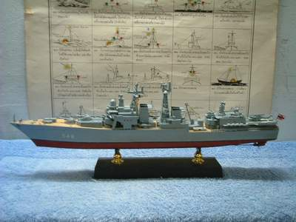
Now let’s take a look to those thirteen detailed pictures .-
PORT SIDE VIEW
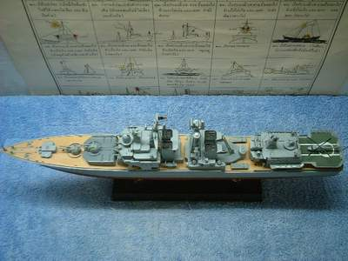
DECK VIEW BY BIRD EYES

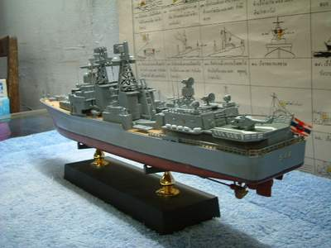
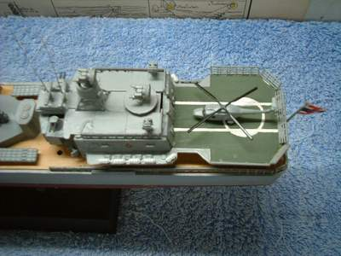
PORT STERN VIEW
BIRD EYES VIEW ON HELICOPTER PAD AND HANGAR

Udaloy class has displacement 6,700 tons (standard) and 8,700 tons (full load ) with overall length 162 meters . Her standard
Armanents consist of two quadruple SS-N-14 Launcher , 8 VLS canisters for SA-N-9 , two 100 mm.guns , four 30 mm. Gatling guns
, two quintuple 21” torpedo launchers , two RBU 6000 rocket launchers.This class of ship is powered by two 30,000 hp. Gasturbines and two
60,000 hp. Gasterbines . She can reach the speed of 35 Knots.
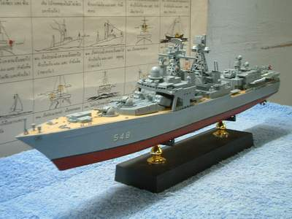
PORT BOW VIEW

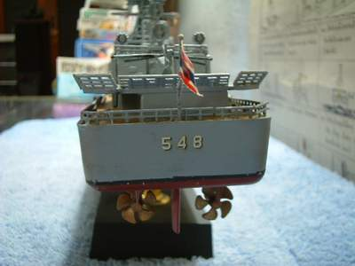
STERN VIEW
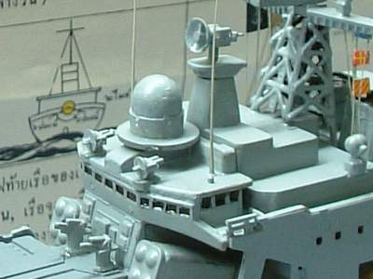
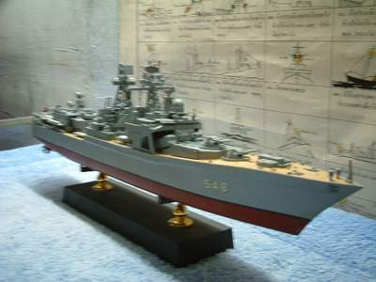
NAVIGATION BRIDGE
STARBOARD BOW VIEW

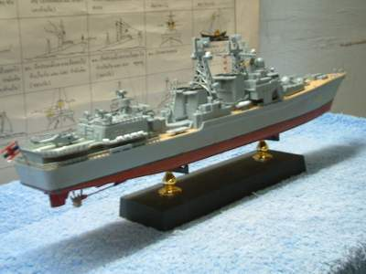
STARBOARD STERN VIEW
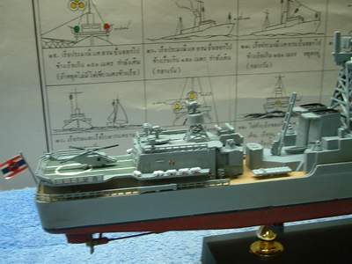
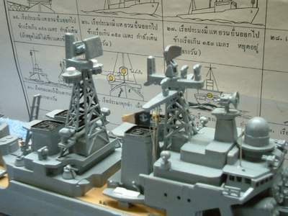
SEA LYNX AND HANGAR
MASTS

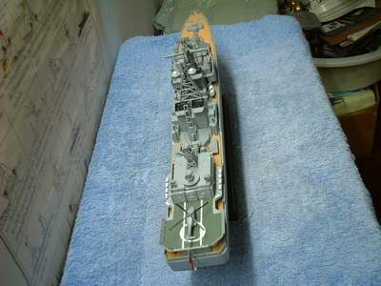
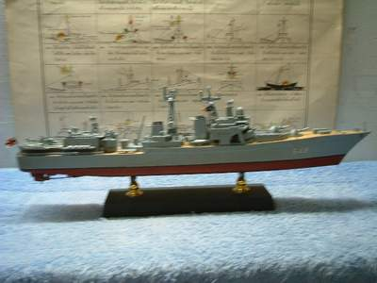
BIRD EYES VIEW FROM STERN
STARBOARD VIEW

